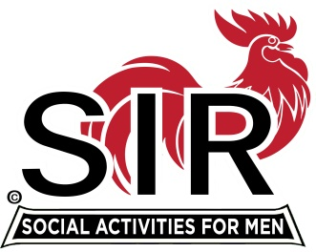
Las Trampas Branch 116
BEC Meeting Agenda
July 18th, 2022, 9:15 AM at Boundary Oaks

The Mission of SIR is to enhance the lives of our members through fun activities, events and luncheons – while making friends for life.

9:15 am Call to order; Secretary, Paul Ramacciotti, confirm a quorum and Approval of June 20th 2022 BEC meeting minutes
9:20 Standing Reports
- Treasurer - Alan Fitzgerald – Report and any points of risk
- Membership – Phil Goff
- RAMP Department Head Reports:
- Recruitment, Don Schroeder
- Activity Coordinator Jeff Johnson standing in for Mike Ward
- Member Relations David Harris (Table Introductions etc.)
- Publicity Al Farbman
- Covid Compliance - Kevin Donahue (BA.5 and any related updates etc.)

9:35 Old Business

- Lunch Estimate Risks and July Boundary accommodation (Mike Schneider)
- Follow-up letter to members (Dues and Membership Confirmation)

9:45 Little SIR Updates – Roger Craig
Speaker Update (Al Farbman and Roger Craig)
Birthday Boys
9:50 Misc. Updates & New Business

- Christmas Party (Chairman needed)
- Chico Branch Position ref female membership
- Guest and new member lunch reimbursement policy options

- Boundary Oaks Branches, Area Branches, and Overlapping Opportunities
  - Contact Plan for Activity Sharing
- Survey: July Release on line survey
- Volunteers Needed: Recruiting Assistants, Speaker Team Member, Member Relations Assistants
- Nomination Process for 2023 Officers

10:15 am Adjourn; For Lunch Preparations

